**Study the Bank Application**

The idea is very simple. The bank has clients and every **Client** can open 2 accounts **SavingAccount** and **CheckingAccount** with overdraft.

Domain objects

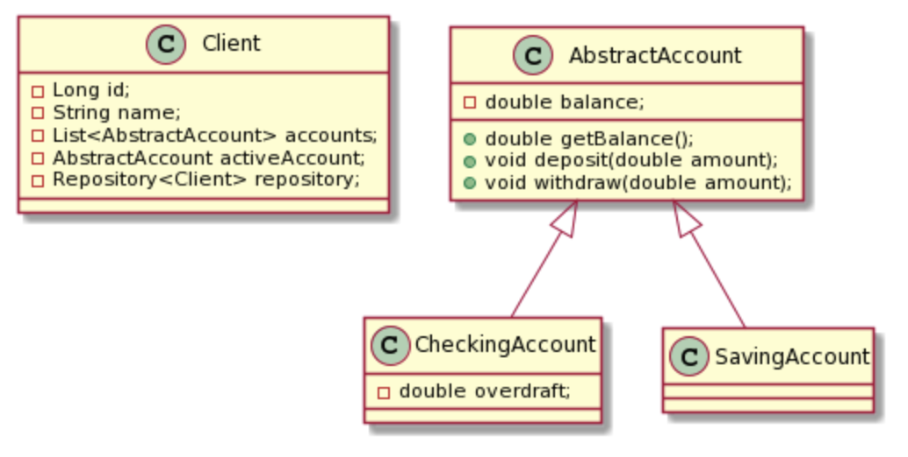

Here there are two main classes:

**AbstractAccount** that represents a bank account.

**Client** that represents a bank client and also contains logic to work with an active account, e.g. deposit, withdraw, and return current balance.

Services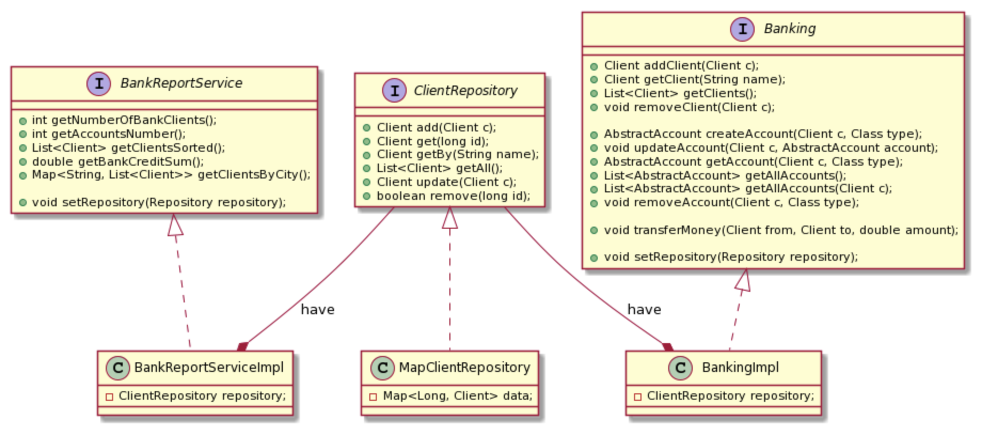

The **Banking** interface serves as a facade to implement all banking operations: working with clients, accounts, global money transfers, etc.

As well, it has a link to **MapClientRepository** (represented with **ClientRepository** interface).

**BankReportService** contains everything related to reports.

**Exercise 1**

**Task 1: Set up banking**

Set up **Spring** and add all services to application context. Services **Banking** and **ClientRepository** should be created and configured via Spring. Banking operations should work as before.

1. Open project **labs/ex1-t1—bank-app**;

2. Open **application-context.xml** from resources folder;

3. Create **ClassPathXmlApplicationContext** using

**application-context.xml** as input in **BankApplication** class;

4. Set up **MapClientRepository** and **BankingImpl** beans using autowire by type for banking to find storage dependency;

5. Modify **initialize** method to get **ApplicationContest** instead of **ClientRepository**;

public static Banking

initialize(ApplicationContext context) {…}

7. Fix compilation error. Replace **BankingImpl** object initialization with code bellow. In this case you will have an object with already injected repository.

Banking banking = (Banking) context.getBean("banking");

6. Make sure methods **workWithExistingClients(Banking)** and **bankingServiceDemo(Banking)** work properly;

Note: All tests from **BankApplicationTask1Tests** should pass.

**Task 2: Configure Reporting**

**BankReportService** should be created and configured with Spring. Logic should not be updated.

1. Add **BankReportServiceImpl** to **application-context.xml**;

2. Modify the **bankReportsDemo** method to get **ApplicationContest** instead of **ClientRepository**;

public static void

bankReportsDemo(ApplicationContext context) {…}

3. Fix compilation error. Replace **BankReportServiceImpl** object initialization with code bellow. In this case you will have an object with already injected repository.

BankReportService reportService =

(BankReportService) context.getBean("bankReport");

. Make sure methods **bankReportsDemo(ApplicationContext)** work properly;

Note: All tests from **BankApplicationTask2Tests** should pass.

**Task 3: Configure Clients**

Here we are configuring and adding two clients inside the **BankApplication** class.

**Banking initialize(ApplicationContext context)**

We need these clients and accounts to demo the application after start. You should move these clients to a separate Spring configuration file. Then get these clients from **Spring** context and add to **Banking**.

1. Create and add **test-clients.xml** to resources folder. (It is better to copy **application-context.xml**, rename it, and remove all the beans.);

2. Add this file to **ClassPathXmlApplicationContext;**

3. Now we should import **application-context.xml** to **test-clients.xml** because we will need some beans from this file;

Configure two beans:

4. Bean **savingAccount1** with **initialBalance** value **1000;**

5. Bean **checkingAccount1** with **overdraft** value **1000;**

6. Configure bean **client1** with **name** *Jonny Bravo*, also set **gender**, **repository** and **accounts** properties;

* Note that we already have **repository** configured in **application-context.xml**
* Also you should add setter method for **accounts** to the **Client** class

7. Replace **client_1** with bean **client1** inside **BankApplication#initialize(ApplicationContext context)** method;

8. Check everything should work as before;

Note: All tests from **BankApplicationTask1Tests** and **BankApplicationTask2Tests** should pass.

9. Repeat points 4-7 for **client_2** and check the results.

* Note that **client_2** has only one checking account with overdraft of 1500 and name **Adam Budzinski**.

10. Check everything should work as before;

Note: All tests from **BankApplicationTask1Tests** and **BankApplicationTask2Tests** should pass.

Now we have only one issue. We should put all test data like client names, cities, etc. to .xml file.

11. Create **clients.properties** file and fill it with test data like this:

**client1**=**Jonny Bravo**

**client2**=**Adam Budzinski**

**client3**=**Anna Smith**

Now when we have this file we can set up Spring to read it and replace all values with needed names. Also you can put their cities, account balances, etc.

12. Configure a new bean with **PropertyPlaceholderConfigurer** class and set **clients.properties** to location property;

<bean class="org.springframework.context.support.PropertySourcesPlaceholderConfigurer">

<property name="location" value="clients.properties"/>

</bean>

13. Replace all values with placeholders from **clients.properties.** Use this syntax **${key_from_file};**

14. Import **application-context.xml** to **test-clients.xml**

<import resource="application-context.xml"/>

15. Check your work. All tests should pass.

**Exercise 2**

**Task 1: Annotation Based Dependencies**

In this task we move all dependency configuration from **application-context.xml** to annotations.

1. To enable annotation processing, add to your **application-context.xml** (next line on top)

<context:annotation-config />

2. Remove **autowire** attribute from the **banking** bean configuration;

3. Mark **repository** field of **BankingImpl** class with @Autowired annotation;

4. Check your work. All tests from **BankApplicationTask1Tests** should pass.

5. Remove **repository** property from the **bankReport** bean configuration;

6. Mark **storage** field of **BankReportServiceImpl** class with @Autowired annotation;

7. Check your work. All tests should pass.

**Exercise 3**

**Task 1: Java Based Configuration**

In this task we move configuration from **application-context.xml** to annotations and remove this file from the project. After refactoring we will have Java Based Spring configuration with no xml.

1. Add @Service annotations to **MapClientRepository**, **BankingImpl**, **BankReportServiceImpl**;

2. Add @Configuration and @ComponentScan("com.luxoft.bankapp") annotations to **BankApplication** class;

3. Open **BankApplication** class and replace **ClassPathXmlApplicationContext** class with

**AnnotationConfigApplicationContext**;

ApplicationContext context = new

AnnotationConfigApplicationContext(BankApplication.class);

5. Remove **application-context.xml** file;

6. Check your work. All tests from **BankApplicationTask1Tests**, **BankApplicationTask2Tests**, should pass.

**Task 2: Java Based Configuration (for test clients)**

In this task we move configuration from **test-clients.xml** to **BankApplication** class and remove this file from the project. After refactoring we will have Java Based Spring configuration with no xml at all.

1. Open **BankApplication** class;

2. Add @PropertySource("classpath:clients.properties")annotation;

3. Add property:

@Autowired

**private** ApplicationContext **applicationContext**;

4. Add property:

@Autowired

**private** Environment **environment**;

5. Configure the **ChekingAccount** bean with next code:

@Bean(name = **"checkingAccount2"**)

**public** CheckingAccount getDemoCheckingAccount2()

{

**return new** CheckingAccount(1500);

}

6. Configure **Client** bean with next code:

@Bean(name = **"client2"**)

**public** Client getDemoClient2()

{

String name = **environment**.getProperty(**"client2"**);

Client client = **new** Client(name, Gender.***MALE***);

client.setCity(**"Kiev"**);

AbstractAccount checking = (CheckingAccount)

**applicationContext**.getBean(**"checkingAccount2"**);

client.addAccount(checking);

**return** client;

}

6. Configure the **client1** bean in the same way as we did for **client2**;

*Note: **client1** should have 2 accounts! **checkingAccount1** and **savingAccount1** as we have before in xml.

7. Now you should have 5 configured beans **client1**, **client2**, **checkingAccount1**, **checkingAccount2**, and **savingAccount1**;

8. Open the **BankApplication#initialize** method and replace clients creation with next code:

Client client_1 = (Client) context.getBean("client1");

Client client_2 = (Client) context.getBean("client2");

9. Remove **test-clients.xml** file;

10. Open the **BankApplication#bankReportsDemo** method and replace code to get **reportService** with next code:

BankReportService reportService =

context.getBean(BankReportService.class);

11. Open the **BankApplication#bankingServiceDemo** method and replace code to get **banking** with next code:

Banking banking = context.getBean(Banking.class);

Also update method declaration to:

public static void

bankingServiceDemo(ApplicationContext context) {…}

12. Do step 11 for the **BankApplication#workWithExistingClients**

method.

13. Check your work. All tests should pass.

**Exercise 4**

**Task 1: Switch to Spring Boot**

In this task we should open <https://start.spring.io/> - select all dependencies and generate a new application. This is done, so go to the application, open the project and study.

**Task 2: Profiles Configuration**

In this task we configure dev and prod profiles using application properties and move bank initialization logic from the **BankApplication** class to a separate service.

1. Rename **application.properties** file to **application.yml;**

2. Configure profiles **dev** and **prod** with different **debug** options;

Your configuration should look like this:

**spring.profiles.active**: dev

---

**spring**:

**profiles**: dev

**debug**: true

---

**spring**:

**profiles**: prod

**debug**: false

And now we should configure **DemoBankInitializationService.**

3. Mark **DemoBankInitializationService** with annotation **@Profile("dev")**;

4. Add the **BankFeedServiceImpl** field with **@Autowired** annotation;

5. Now we need to make sure that demo clients created after application will start, so we mark method **createClientsForDemo** with **@PostConstruct** annotation;

6. Implement **createClientsForDemo** with the next code:

**feedService.loadFeed(new File("demo.feed"));**

7. Remove everything from the **BankApplication** class; the main method should contain only application run code:

**SpringApplication.run(BankApplication.class, args);**

8. Check your work. All tests from **BankApplicationTests1** should pass.

**Task 3: Custom Feed File Name**

In this task we configure **DemoBankInitializationService** to use a custom feed file name (if it exists in configuration).

1. Open **DemoBankInitializationService** and add **fileName** field with **@Value** annotation:

**@Value("${feed.filename}")**

**private String fileName;**

2. Update **createClientsForDemo** method to use this field (if not null):

**@Override**

**@PostConstruct**

**public void createClientsForDemo()**

**{**

**if (fileName == null)**

**{**

**fileName = DEMO_FEED_FILE_NAME;**

**}**

**feedService.loadFeed(new File(fileName));**

**}**

3. Add **feed.filename: demo.feed** property to **application.yml**

4. Check your work. All tests from **BankApplicationTests2** should pass.

**Exercise 5**

**Task 1: Banking Operations**

In this task we will add a service to work with client accounts: deposit, withdraw, and check balance.

1. Open **ex5-task1-bankapp** project;

2. Look to the **com.luxoft.bankapp.service.operations** package. You will find **BankingOperationsServiceImpl** service;

3. **BankingOperationsServiceImpl** class that implements **BankingOperationsService** and mark it with **@Service** annotation.

4. All methods already implemented. Check your work with **BankApplicationTests3**. All tests should pass.

**Task 2: Audit Service**

In this task we will add **AuditService** that logs banking operations. Then we’ll add **AuditAspect** to monitor every call from **BankingOperationsService** and call the appropriate method from **AuditService**.

1. Add **spring-boot-starter-aop** to **pom.xml** dependency list:

**<dependency>**

**<groupId>org.springframework.boot</groupId>**

**<artifactId>spring-boot-starter-aop</artifactId>**

**</dependency>**

2. Create the **com.luxoft.bankapp.service.audit** package;

3. Create an empty **Audit** interface;

4. Create enum **WithdrawState** with **TRYING**, **SUCCESSFUL**, and **FAILED** values. We will log user actions before and after withdrawal with appropriate states;

Use the code below:

**public enum WithdrawState**

**{**

**TRYING, SUCCESSFUL, FAILED**

**}**

5. Now add next methods to **Audit** interface:

**public interface Audit**

**{**

**void auditDeposit(long accountId, double amount);**

**void auditWithdraw(long accountId, double amount, WithdrawState state);**

**void auditBalance(long accountId);**

**}**

6. Create **AuditService** class that implements **Audit** and mark it with **@Service** annotation;

It should contain the next code:

**@Service**

**public class AuditService implements Audit**

**{**

**@Override**

**public void auditDeposit(long accountId,**

**double amount)**

**{**

**System.out.println("ACCOUNT ID: "**

**+ accountId + " DEPOSIT: " + amount);**

**}**

**@Override**

**public void auditWithdraw(long accountId,**

**double amount, WithdrawState state)**

**{**

**System.out.println("ACCOUNT ID: "**

**+ accountId + " " + state**

**+ " WITHDRAWAL: " + amount);**

**}**

**@Override**

**public void auditBalance(long accountId)**

**{**

**System.out.println("ACCOUNT ID: “**

**+ accountId + " BALANCE CHECK");**

**}**

**}**

Very good! Now only one step is left. We should create an aspect that connects these two services.

7. Create **AuditAspect** class and mark it with **@Configuration** and **@Aspect** annotations;

8. Add the **Audit** property to have an ability to log events:

**@Autowired**

**private Audit audit;**

9. Then create pointcuts for operations. We should know when these methods are executing:

**@Pointcut("execution(* com.luxoft.bankapp.service.operations.*.deposit(..))")**

**public void anyDeposit() {}**

**@Pointcut("execution(* com.luxoft.bankapp.service.operations.*.withdraw(..))")**

**public void anyWithdraw() {}**

**@Pointcut("execution(* com.luxoft.bankapp.service.operations.*.getBalance(..))")**

**public void anyBalance() {}**

10. Create method **getAccountId** which we will use to extract **accountId** from method arguments;

Use the code below:

**private long getAccountId(Object[] methodArgs)**

**{**

**Account account;**

**if (methodArgs[0] instanceof Client)**

**{**

**account = ((Client) methodArgs[0])**

**.getActiveAccount();**

**}**

**else**

**{**

**account = (Account) methodArgs[0];**

**}**

**return account.getId();**

**}**

11. Create **@Before** advice for deposit operation and fire event (before the method is called);

Use the code below:

**@Before("anyDeposit()")**

**public void logDeposit(JoinPoint joinPoint)**

**{**

**Object[] methodArgs = joinPoint.getArgs();**

**audit.auditDeposit(getAccountId(methodArgs),**

**(double) methodArgs[1]);**

**}**

12. Check your work. Run the tests from **BankApplicationTests4 deposit\*** which should all pass;

13. Create **@Before** advice for balance operation yourself and run the test again. Now the **getClientBalance** test should pass too.

Good! Only one more step:

14. Create **@Around** advice for withdraw operation and log user actions (before and after method call). First log will have a **TRYING** status and second will have **SUCCESSFUL** or **FAILED** accordingly.

Use the code below:

**@Around("anyWithdraw()")**

**public Object logWithdrawal(ProceedingJoinPoint thisJoinPoint) throws Throwable**

**{**

**Object[] methodArgs = thisJoinPoint.getArgs();**

**long accountId = getAccountId(methodArgs);**

**audit.auditWithdraw(accountId,**

**(double) methodArgs[1], WithdrawState.TRYING);**

**Object result;**

**try**

**{**

**result = thisJoinPoint.proceed();**

**audit.auditWithdraw(accountId,**

**(double) methodArgs[1],**

**WithdrawState.SUCCESSFUL);**

**}**

**catch (Exception e)**

**{**

**audit.auditWithdraw(accountId,**

**(double) methodArgs[1],**

**WithdrawState.FAILED);**

**throw e;**

**}**

**return result;**

**}**

15. Check your work. Run the tests from **BankApplicationTests4** which should all pass.

**Task 3: Audit Service Events**

Currently, our **AuditAspect** relies on **Audit** service to log all operations. This creates unnecessary dependency. In this task we will refactor **Audit** service and **AuditAspect** to use the Spring events mechanism (instead of direct method calls).

1. Create **com.luxoft.bankapp.service.audit.events** package;

2. Create abstract class **AccountEvent** that extends **ApplicationEvent** with the next code:

**public abstract class AccountEvent extends ApplicationEvent**

**{**

**private long accountId;**

**public AccountEvent(Object source, long accountId)**

**{**

**super(source);**

**this.accountId = accountId;**

**}**

**public long getAccountId()**

**{**

**return accountId;**

**}**

**}**

3. Then create 3 event classes: **BalanceEvent**, **DepositEvent**, and **WithdrawEvent**. All these classes should extend **AccountEvent**:

* **BalanceEvent** and **DepositEvent** events are pretty simple, just data;
* **WithdrawEvent** event also will contain **State** with **TRYING**, **SUCCESSFUL**, and **FAILED** values. We will send two events (before withdrawal and after with appropriate states).

Use the code below:

**public class BalanceEvent extends AccountEvent**

**{**

**public BalanceEvent(long accountId)**

**{**

**super("BALANCE CHECK", accountId);**

**}**

**}**

**public class DepositEvent extends AccountEvent**

**{**

**private double amount;**

**public DepositEvent(long accountId, double amount)**

**{**

**super("DEPOSIT", accountId);**

**this.amount = amount;**

**}**

**public double getAmount()**

**{**

**return amount;**

**}**

**}**

**public class WithdrawEvent extends AccountEvent**

**{**

**private double amount;**

**private State state;**

**public WithdrawEvent(long accountId, double amount)**

**{**

**super("WITHDRAWAL", accountId);**

**this.amount = amount;**

**this.state = State.TRYING;**

**}**

**public WithdrawEvent(long accountId, double amount, State state)**

**{**

**super("WITHDRAWAL", accountId);**

**this.amount = amount;**

**this.state = state;**

**}**

**public double getAmount()**

**{**

**return amount;**

**}**

**public State getState()**

**{**

**return state;**

**}**

**public enum State**

**{**

**TRYING, SUCCESSFUL, FAILED**

**}**

**}**

4. Once events are ready to use, replace all methods from **Audit** interface:

**public interface Audit**

**{**

**void auditOperation(DepositEvent event);**

**void auditOperation(WithdrawEvent event);**

**void auditOperation(BalanceEvent event);**

**}**

5. Update the **AuditService** class that implements **Audit** with the next code:

**@Service**

**public class AuditService implements Audit**

**{**

**private List<AccountEvent> events;**

**public AuditService()**

**{**

**this.events = new ArrayList<>(100);**

**}**

**@Override**

**@EventListener**

**public void auditOperation(DepositEvent event)**

**{**

**events.add(event);**

**System.out.println("ACCOUNT ID: "**

**+ event.getAccountId() + " "**

**+ event.getSource() +**

**": " + event.getAmount());**

**}**

**@Override**

**@EventListener**

**public void auditOperation(WithdrawEvent event)**

**{**

**events.add(event);**

**System.out.println("ACCOUNT ID: "**

**+ event.getAccountId() + " "**

**+ event.getState() + " "**

**+ event.getSource() + ": "**

**+ event.getAmount());**

**}**

**@Override**

**@EventListener**

**public void auditOperation(BalanceEvent event)**

**{**

**events.add(event);**

**System.out.println("ACCOUNT ID: "**

**+ event.getAccountId() + " "**

**+ event.getSource());**

**}**

**public List<AccountEvent> getEvents()**

**{**

**return new ArrayList<>(events);**

**}**

**}**

5. Remove **WithdrawState** which is not needed anymore, as now we have **State** as inner enum within **WithdrawEvent**. Now it’s time to update **AuditAspect**;

6. Add **applicationContext** property to have an ability to publish events:

**@Autowired**

**private ApplicationContext applicationContext;**

7. Remove the **audit** property from the class;

8. Open the **logDeposit** method and replace **audit** call with the next code:

**applicationContext.publishEvent(**

**new DepositEvent(getAccountId(methodArgs),**

**(double) methodArgs[1]));**

9. Open the **logBalance** method and replace **audit** call with the next code:

**applicationContext.publishEvent(**

**new BalanceEvent(getAccountId(methodArgs)));**

10. Open the **logWithdrawal** method and replace **audit** calls with the next code:

a. before **thisJoinPoint.proceed()**

**applicationContext.publishEvent(**

**new WithdrawEvent(getAccountId(methodArgs),**

**(double) methodArgs[1]));**

b. after successful result

**applicationContext.publishEvent(**

**new WithdrawEvent(getAccountId(methodArgs),**

**(double) methodArgs[1],**

**WithdrawEvent.State.SUCCESSFUL));**

c. after exception

**applicationContext.publishEvent(**

**new WithdrawEvent(getAccountId(methodArgs),**

**(double) methodArgs[1],**

**WithdrawEvent.State.FAILED));**

11. Fix tests. Use the code below to replace all tests from **BankApplicationTests4**:

**import static org.junit.jupiter.api.Assertions.assertEquals;**

**import static org.junit.jupiter.api.Assertions.assertThrows;**

**@SpringBootTest(classes = BankApplication.class)**

**public class BankApplicationTests4**

**{**

**@Autowired**

**private Banking banking;**

**@Autowired**

**private BankingOperationsService**

**bankingOperationsService;**

**@Autowired**

**private AuditService auditService;**

**private Client client;**

**@BeforeEach**

**public void init()**

**{**

**client = banking.getClient("Jonny Bravo");**

**client.setDefaultActiveAccountIfNotSet();**

**client.getActiveAccount().setId(999);**

**}**

**@Test**

**public void depositToClient1()**

**{**

**double amount = 100;**

**int countOfEvents =**

**auditService.getEvents().size();**

**bankingOperationsService.deposit(client, amount);**

**assertEquals( countOfEvents + 1,**

**auditService.getEvents().size());**

**}**

**@Test**

**public void depositToClient2()**

**{**

**Account account = client.getActiveAccount();**

**double amount = 100;**

**int countOfEvents =**

**auditService.getEvents().size();**

**bankingOperationsService**

**.deposit(account, amount);**

**assertEquals( countOfEvents + 1,**

**auditService.getEvents().size());**

**}**

**@Test**

**public void getClientBalance()**

**{**

**int countOfEvents =**

**auditService.getEvents().size();**

**bankingOperationsService.getBalance(client);**

**assertEquals( countOfEvents + 1,**

**auditService.getEvents().size());**

**}**

**@Test**

**public void withdrawFromClient1()**

**{**

**double amount = 100;**

**int countOfEvents =**

**auditService.getEvents().size();**

**bankingOperationsService**

**.withdraw(client, amount);**

**assertEquals( countOfEvents + 2,**

**auditService.getEvents().size());**

**}**

**@Test**

**public void withdrawFromClient2()**

**{**

**Account account = client.getActiveAccount();**

**double amount = 100;**

**int countOfEvents =**

**auditService.getEvents().size();**

**bankingOperationsService**

**.withdraw(account, amount);**

**assertEquals( countOfEvents + 2,**

**auditService.getEvents().size());**

**}**

**@Test**

**public void withdrawFromClient3()**

**{**

**Account account = client.getActiveAccount();**

**double balance = account.getBalance();**

**double overdraft = 0;**

**if (account instanceof CheckingAccount)**

**{**

**overdraft =**

**((CheckingAccount) account).getOverdraft();**

**}**

**double amount = balance + overdraft + 1000;**

**int countOfEvents =**

**auditService.getEvents().size();**

**assertThrows(NotEnoughFundsException.class,**

**() ->**

**bankingOperationsService**

**.withdraw(account, amount));**

**assertEquals(auditService.getEvents().size(),**

**countOfEvents + 2);**

**}**

**}**

12. Check your work. Run the tests from **BankApplicationTests4** whichshould all pass.

**Task 4: Filtering Audit Events**

Currently, our **AuditService** logs every event (deposit, withdrawal, balance). We need an ability to limit it down and at the same time we don’t want to change the code. So, in this task we will add a specific property that will help **AuditService** to make a final decision.

1. Open **application.yml** and add the next properties:

**audit.amount:**

**deposit: 99**

**withdrawal: 99**

2. Go to the **com.luxoft.bankapp.service.audit** package and create class **EventConditionFilter** with the next code:

**@Component**

**public class EventConditionFilter**

**{**

**@Value("${audit.amount.deposit}")**

**public double depositLimit;**

**@Value("${audit.amount.withdrawal}")**

**public double withdrawalLimit;**

**}**

1. Open AuditService and update our **@EventListener** annotations for **auditOperation(..)** methods for **deposit** and **withdrawal**. Note that we need to put **@** before the bean name to make it visible for SpEL.

Use the code below:

**@EventListener(condition = "#event.amount**

**>= @eventConditionFilter.depositLimit")**

**@EventListener(condition = "#event.amount**

**>= @eventConditionFilter.withdrawalLimit")**

4. Check your work using tests from **BankApplicationTests4** now (all the tests should pass as before). But if you changed the **deposit** or **withdrawal** property to any value greater than **100,** thetests could fail because of our new event filtering.